

**PAMANTASAN NG LUNGSOD NG MAYNILA**

College of Information Systems and Technology Management (CISTM)

**ICC 0104-1 – Data Structures and Algorithms**

*A.Y. 2023- 2024*

**Group 4**: Searching

**Submitted by**:

Abundo, Jonalene Ryza B.

Dela Peña, Daniella Mae N.

Diamzon, Momer Ailes M.

Lau, Trisha Mae R.

Mahusay, Lindsay G.

Matanga, Sophia Vien V.

Rivera, Ramyll C.

Sibayan, Joan F.

BSCS 1-1

1. **Main Menu**

Source Code in C++

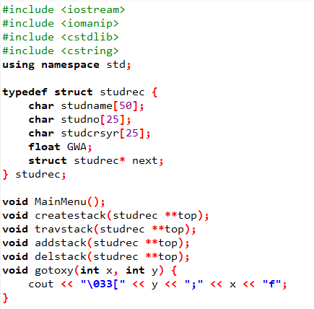

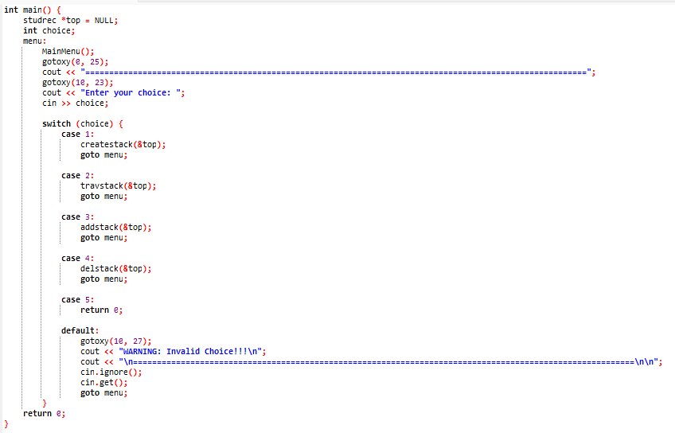

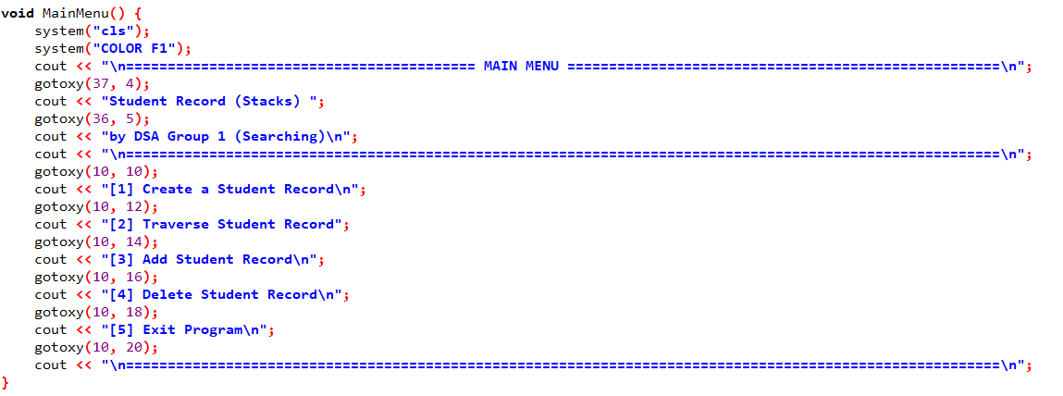

Output

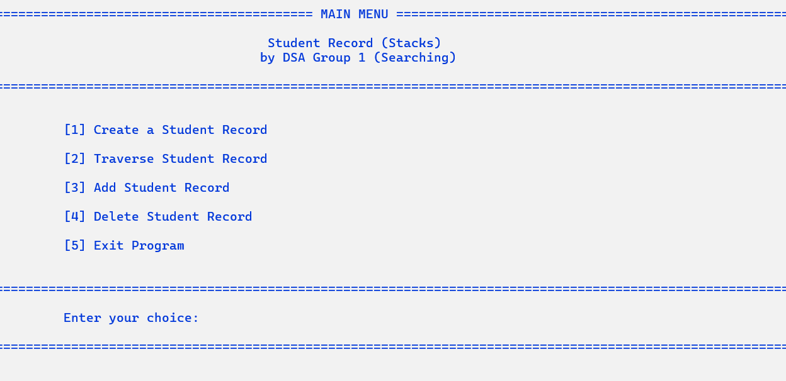

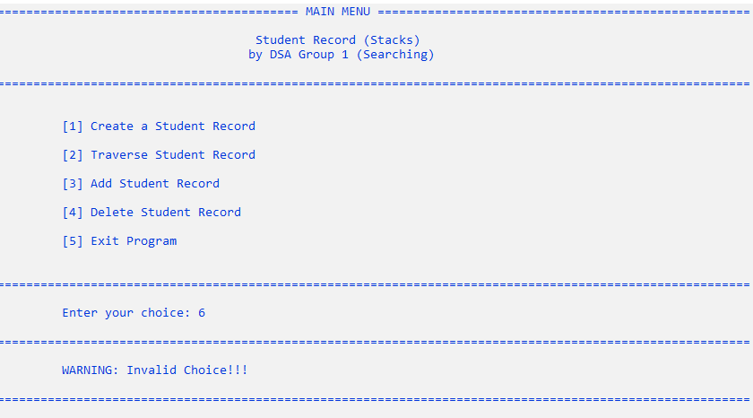

*(Figure 1: Main Menu – Functions)*

1. **Creation of Stack**

Source Code in C++

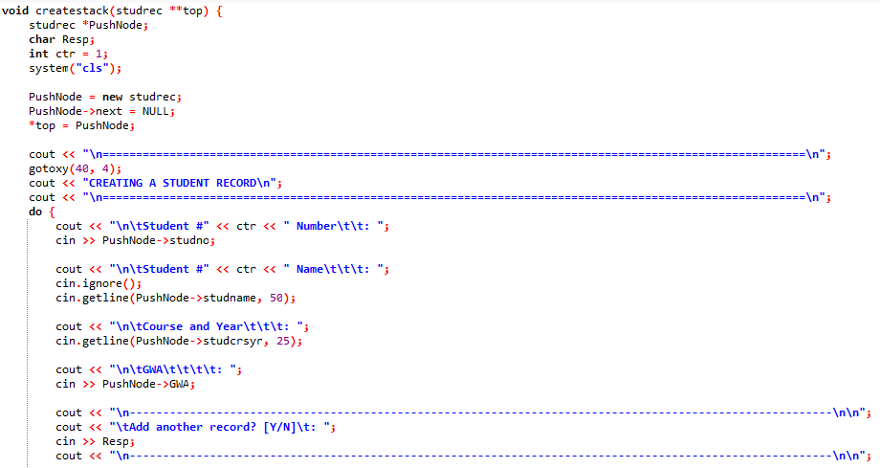

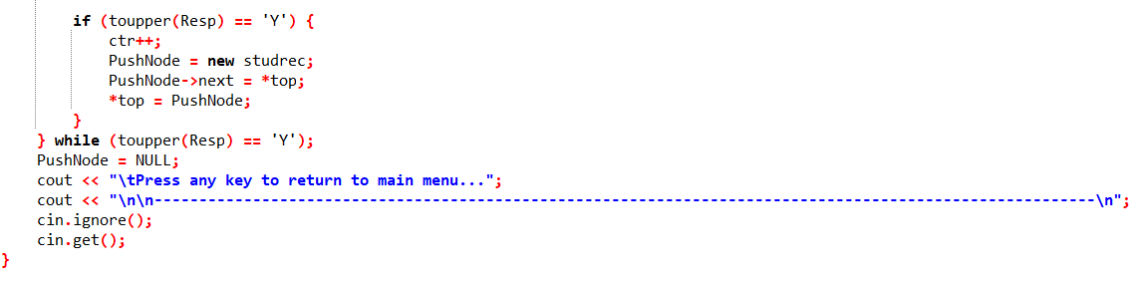

Output

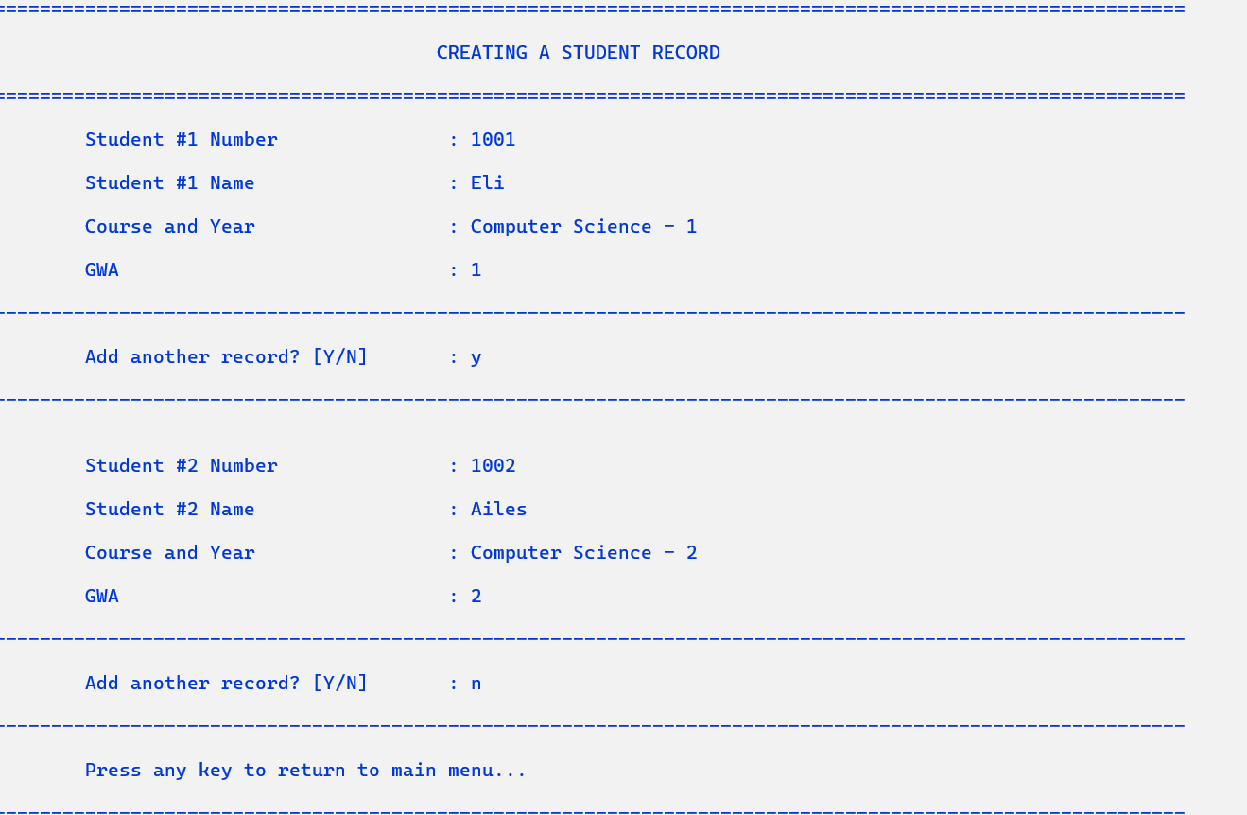

*(Figure 2: Creating a Student Record in Stacks)*

1. **Traversal of Stack**

Source Code in C++

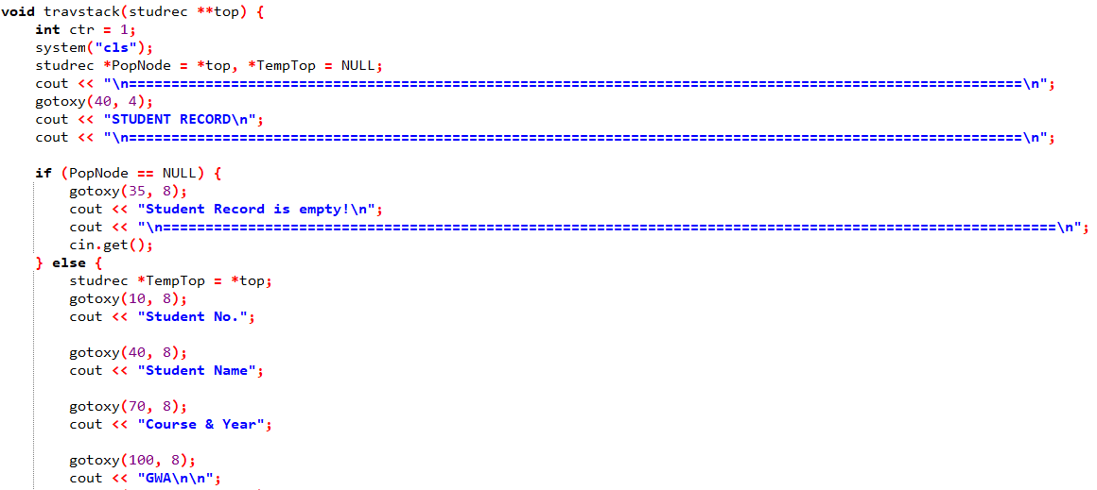

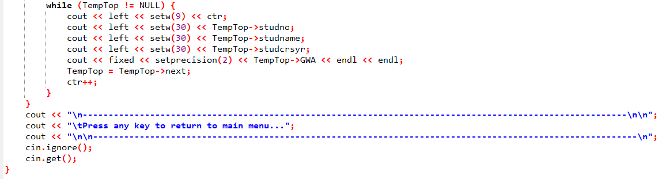

Output

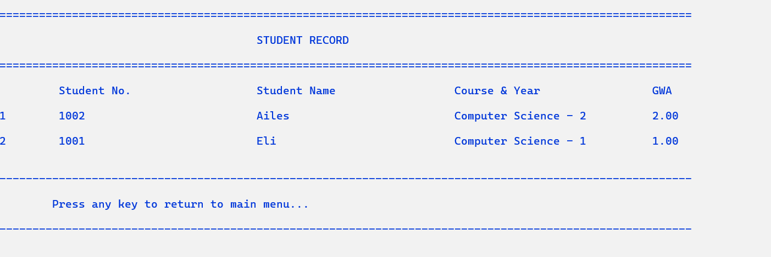

*(Figure 3.1: Displaying the Student’s GWA Report in Tabulated Format)*

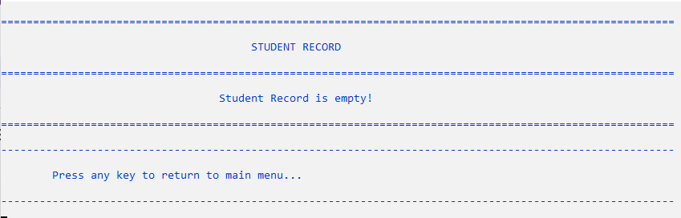

*(Figure 3.1: Student Record is Empty)*

1. **Adding of Node in Stack**

Source Code in C++

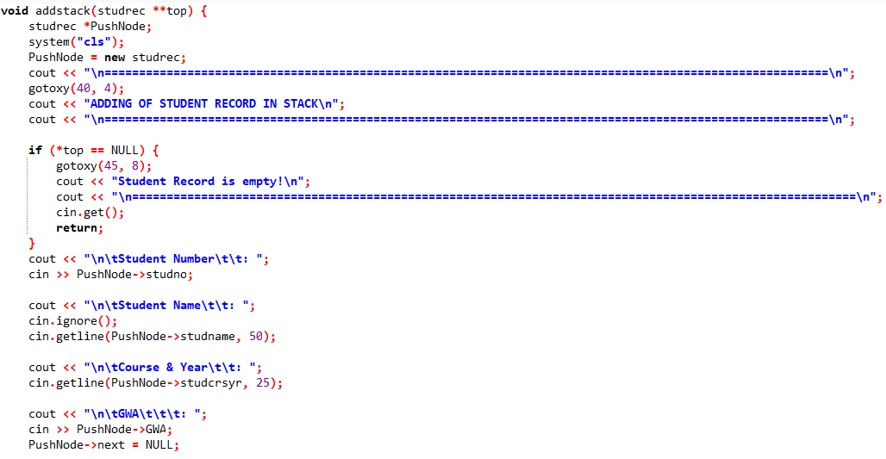

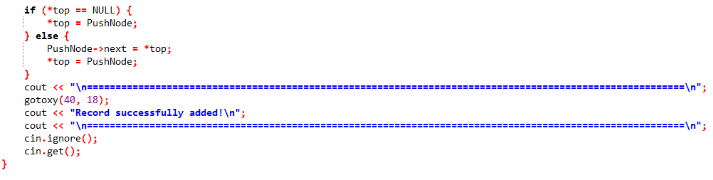

Output

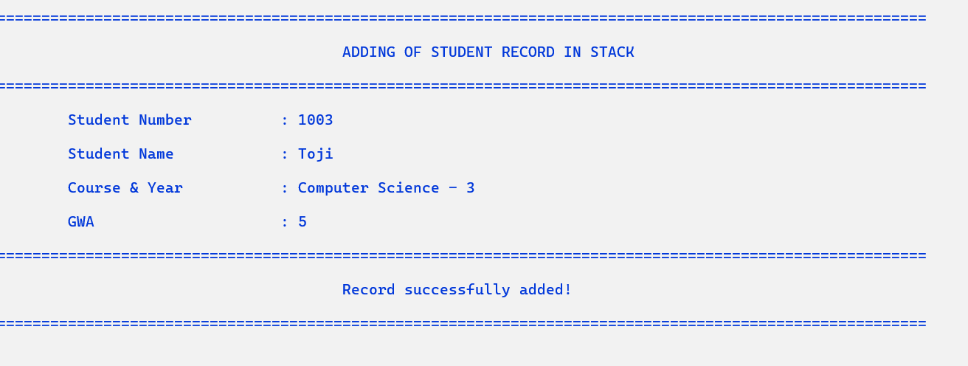

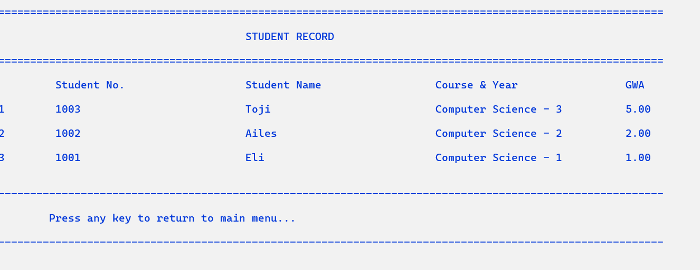

*(Figure 4: Adding a Student Record in Stacks)*

1. **Deletion of Node in Stack**

Source Code in C++

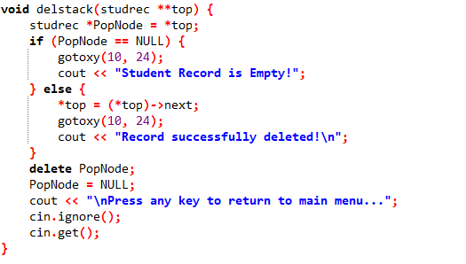

Output

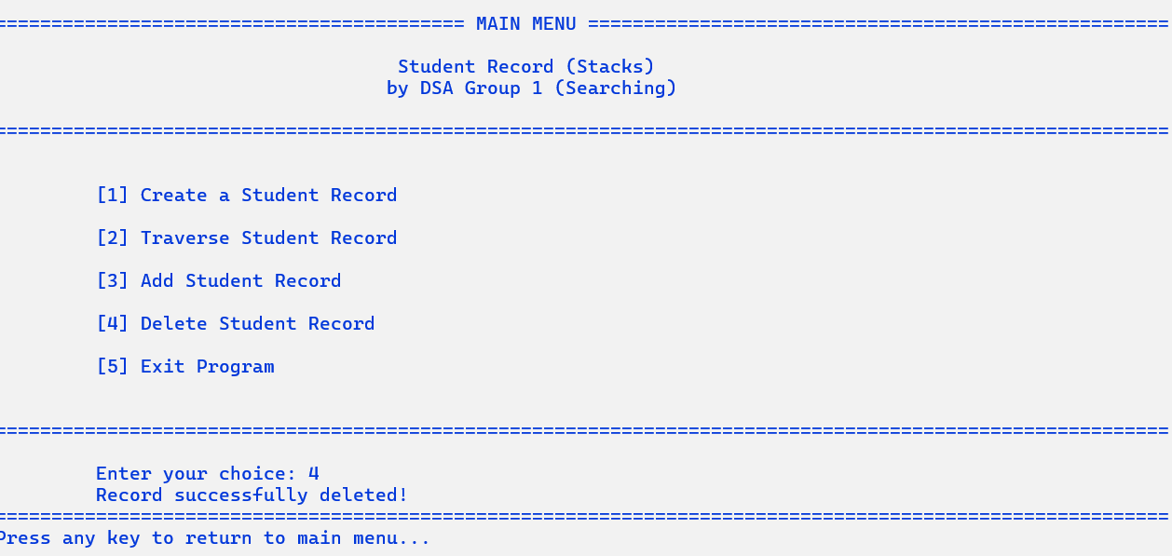

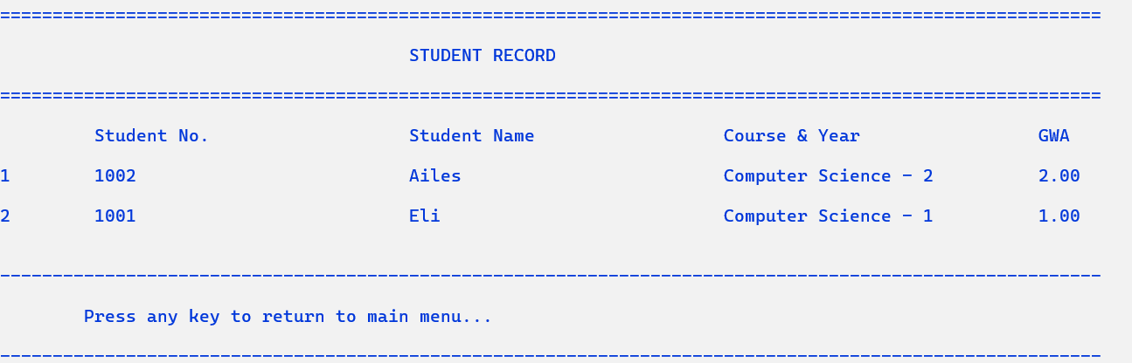

*(Figure 5: Deleting a Student Record in Stacks)*